Bond Eternal
Joel “Mole” Setaro (Pimentel), S’72

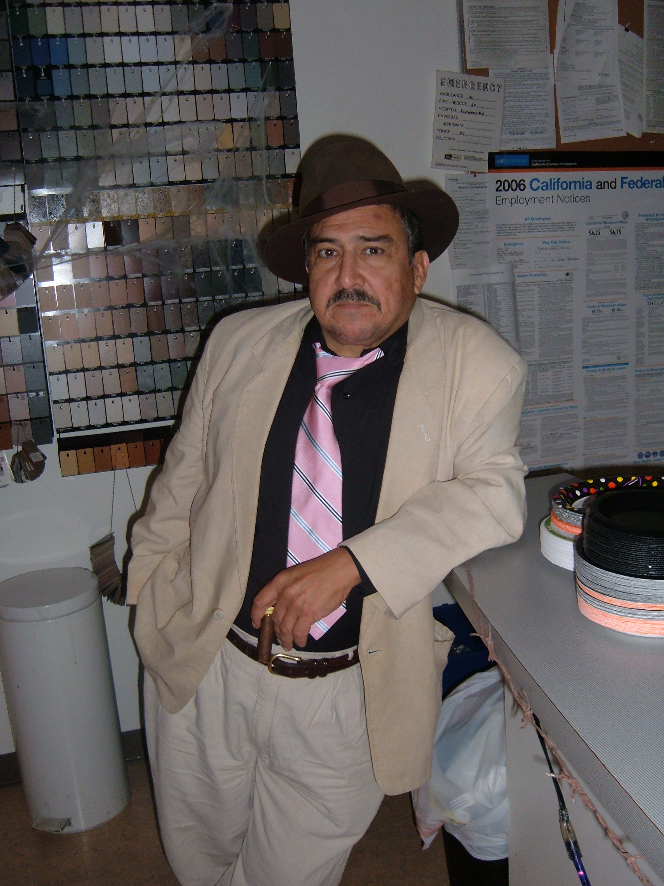
On September 1st and 2nd the Fraternity bid farewell to Brother Mole, a member of “New House”, S’72, the first pledge class at 244 California. Joel was an architect, artist, and author, and an original and irreverent character and RF-master. He had fallen into a coma August 5th from complications of diabetes and passed away, at age 58, on August 25th.

Joel was known to many DSP eras for mentoring younger members, teaching brotherhood, and faithfully returning and supporting our chapter. Thirty-six Delta Sigs from across 25 years, and their family members, attended his memorial services. After Mass, brothers participated in Delta Sigma Phi’s national Bond Eternal ceremony, offering a carnation and farewell to Joel in a brief, but deeply moving, ritual. Dozens of other brothers, unable to attend, sent best wishes.

Two days prior to entering the coma, Joel made a last request of us. He asked us to establish a small scholarship in his name. I quote: for a “Yitbos who display(s) the true qualities of Brotherhood. They wouldn't have to be the best students or the best athletes, just someone who kept the real meaning of the House alive.”

In recognition of his work for DSP, the Alumni Association has established this fund for Mole. If you wish to contribute, please make your check payable to DSP EP Alumni Assn., put "Joel's Scholarship" in the memo, and mail it with your name, nickname, class, and email address to Alumni Assn. Officer Martin Ernst (“Beads”, W’74) at 4601 Jacksol Drive, San Jose, CA 95124-3317.

Delta Sigs and their families that attended:

John “Si’mon” & Dian Kerr, S’58
Bill “Fubar” Bradley, F’62
Greg “Deuce” & Barb Piers, F’67
Mike “Harpo” & Dea Roanhaus, S’70
Jeff “Grobo” Weaver, S’70
Joe “FOB” & Tricia Lima, F’70
Mike “Snidley” Ivy, S’71
Steve “Rocky” Miller, S’71
Jim “Ozzie” Nelson, F’71
Jim “Lurch” Larson, W’72
John “Cleat” & Ronalee Lester, W’72
Larry “TA” Everett, W’72
Rob “Ichabod” & Karen Ellery, W’72
Pete “Boomer” Rominger, S’72
Darrel “Shag” Aoki, S’72
Wayne “Dizzy” Kendrick, F’72
Mark “Rollo” Huntley, F’72
Chris “Yabut” & Carol Patterson, W’73
Andrew, Dee, & (toddler) Jack Patterson
Don “Gutter” Wyman, S’73
Bob “Hots” & Peggy Papazian, S’73
Tad “P.T.” Kato, S’73
Ray “Mumbles” & Lourdes Calande, W’74
Martin “Beads” & Joann Ernst, W’74
Bill “Rip” Kordes, W’74
Ben “Coco” Parcasio, S’74
John “Echo” Bann, S’74
Dan “Froggie” Venya, S’74
Ted “BION” & Ann Rupley, S’74
Doug “Spuna” Aitken, F’74
Greg “Mombo” Weaver, F’74
Rich “Boo Boo” Stewart, W’75
Mark “Gumby” Mosely, F’75
Rob “Sparky” Mullaney, F’75
Brian “Stumbles” Crowell, W’78
Mike “Zipp” Chacon, S’80
Jeff “Skeeter” Rogers, F’83

